**Detailed Design Document**

|  |  |
| --- | --- |
| **Project Name** | **5StarGlobalEntertainment-TKCS** |
| **Client Name** | **Chyna Hobbs,**  **Zachary Criss** |

##### Chetu Contacts

This section should list all Chetu team members.

Note: All Chetu emails are of the format: FirstnameLastnameinitial@chetu.com

Note: Chetu (US) team works normal hours EDT and can be reached at: 954-342-5676.

Note: Chetu (India) team works 5am-2pm EDT and can be reached at: 954-862-3901.

|  |  |  |  |
| --- | --- | --- | --- |
| Name | Role | Location | Responsibility |
| Sanjeev Kota | DO | USA | Managing project delivery and operations & Escalation point for any delivery/ quality issues |
| Amit Sinha | PM | USA | Managing overall project & Main point of contact |
| Vineet Mishra | TL | India | Design & development & guiding TM |
| Akhilesh Yadav | Developer | India | Application Developement |

##### Client Contacts

This section should list all customer contacts including project champion and business users.

|  |  |  |  |
| --- | --- | --- | --- |
| Name | Email | Entity | Responsibility |
| Zachary Criss | [zzcriss@yahoo.com](mailto:zzcriss@yahoo.com) | CEO |  |
| Chyna Hobbs | [admin@5starglobalent.com](mailto:admin@5starglobalent.com) | Director of Operations |  |

##### Revision Chart

A new record should be added in this section every time a user updates this document.

|  |  |  |  |
| --- | --- | --- | --- |
| Ver. # | Date | Author | Change |
| v.01232023 | 23/01/2023 | Vineeet Mishra | Initial Draft |
| v.05252023 | 25/05/2023 | Vineet Mishra | Completed |

##### Document Conventions

* *Notations in Italics contain Document instructions and should be preserved*.
* Sections highlighted in **yellow** shall be provided by Client.
* Sections highlighted in **grey** are questions or open items that need to be discussed further.

Contents

1.0 Introduction 4

1.1 Overview 4

1.2 Project Objectives 4

1.3 Approach Summary 4

2.0 FUDs [Fears, Uncertainties and Doubts] 5

3.1 Overview 6

3.2 Development Environment 6

3.2.1 QA Testing Environment 6

3.3 Staging Environment 7

3.4 Production Environment 7

4.0 Requirements recap 8

4.1 Overview 8

4.2 Details 8

5.0 Design Details 9

Diagrams 9

5.1 Use Case Diagram 9

5.1.1 Use Case Detail Description 9

5.1.2 <Use-case 1: GroupCheck-In> 10

5.1.3 <Use-case 2: Name> 10

5.2 Activity Diagram 12

5.3 Class Diagram 13

5.4 Sequence Diagram 14

6.0 User Interface 15

6.1 Overview 15

6.2 Main Page 15

6.2.1 Interface 15

6.2.2 Description 15

6.3 Results Page 15

6.3.1 Interface 15

6.3.2 Description 15

7.0 Database 1

7.1 Overview 16

7.2 ER Diagram 16

8.0 Future Considerations 21

9.0 Change/Update Track Record. (According to Date) 22

# Introduction

## Overview

5StarGlobalEntertainment is the world's largest event technology platform, powering millions of events in multiple countries and territories. We’re building intuitive technology to help you create, manage, and sell tickets to virtual and in-person events – so you can spend less time focusing on online ticket sales and more time creating meaningful live experiences.

5StarGlobalEntertainment is a global self-service ticketing platform for live experiences that allows anyone to create, share, find and attend events that fuel their passions and enrich their lives. Our mission is to bring the world together through live experiences.

## Project Objectives

5StarGlobalEntertainment is a global self-service ticketing platform for live experiences that allows anyone to create, share, find and attend events that fuel their passions and enrich their lives. Our mission is to bring the world together through live experiences*.*

## References

### Industry Specific

<https://en.wikipedia.org/wiki/Electronic_ticket>

### Project specific

<https://en.wikipedia.org/wiki/Event_management>

# FUDs [Fears, Uncertainties and Doubts]

N/A

**2.0 FUDS**

# Environment

## Overview

We need to build a complete Event Management and ticketing platform from scratch. It will have a Role based access for Promoters and Venues to add/manage Events. The application will have ticketing, QR Codes, Payment processing features. The users can search and purchase tickets from this platform.

## Development Environment

Below are the Technologies and platform used for development:

Language : Swift

Application : iOS Application

Operating System : iOS

IDE : XCode

Framework : iOS

Pattern : MVVM

Database : UserDefaults

ORM : N/A

Others : N/A

### QA Testing Environment

*Please specify targested browsers, mobile devices versions and Operating Systems*

#### OS Systems

* iOS

#### Browsers

* Safari
* Chrome

#### Devices only if provided by client. Simulator otherwise

* *Simulator*

## Staging Environment

* *We are using Chetu DBProd for now*

## Production Environment

NA

# Requirements recap

## Overview

Customer is looking to build a complete Event Management and ticketing platform from scratch. It will have a Role based access for Promoters and Venues to add/manage Events. The application will have ticketing, QR Codes, Payment processing features. The users can search and purchase tickets from this platform.

## Details

**Phase -1 Development**

**Live Site-End User**

1. Login Module

* Login
* Registration
* Forget/Reset password

1. Home Page
2. Search Event
3. Event List
4. Event Detail
5. Buy Ticket
6. Contact Us
7. Terms & Condition
8. Privacy Policy
9. Event screnn
10. Cart screen
11. Payment checkout
12. Payment Screen
13. Manage user
14. Manage promoter
15. Add category
16. Manage category
17. Event charge
18. Create event
19. My event
20. Event details
21. My puchases
22. Create Ticket
23. Manage Ticket
24. Promotional event
25. Subscriber user list
26. Add banner
27. Manage banner
28. Scan ticket
29. Contact us

## MVVM Architecture

### Overview

As the application is the mobile application, we agreed on using the MVVM architecture.

### Description

MVVM(Model View ViewModel) is a design patter which has been widly used as more event-driven apps have started emerging.

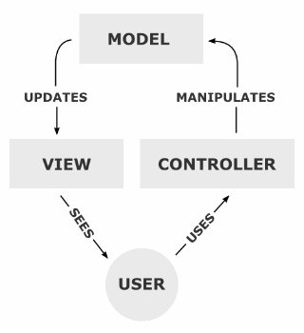

# Design Details

## Diagrams

*Activity and Class.*

## Use Case Diagram

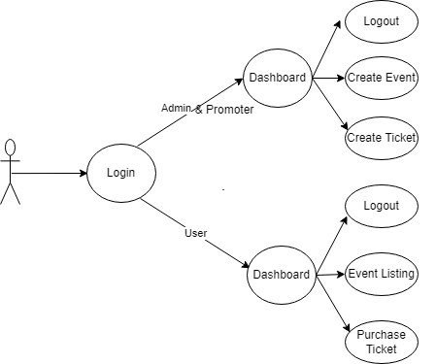

### Use Case Detail Description

Admin and Promoter login with their credentials and able to view its home screen and can create Events and Tickets . User/Buyer can login with their credentials and can only purchase the tickets of the events. The admin and promoter can fill their form as per the requirements. All the changes made by admin will be visible into the users screen.

## Class Diagram

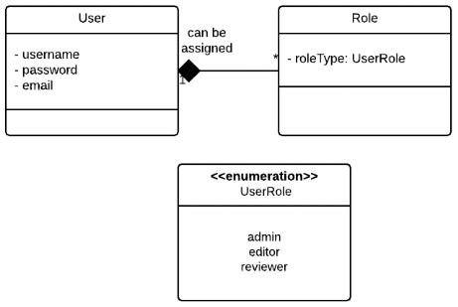

*Class Diagram for relationship between users and roles*

er Interface

## Overview

User has one to many relationship with Role class

Attributes of User class: username, password, email

Attributes of Role class: roleType

## Main Page

### User Login Page Interface

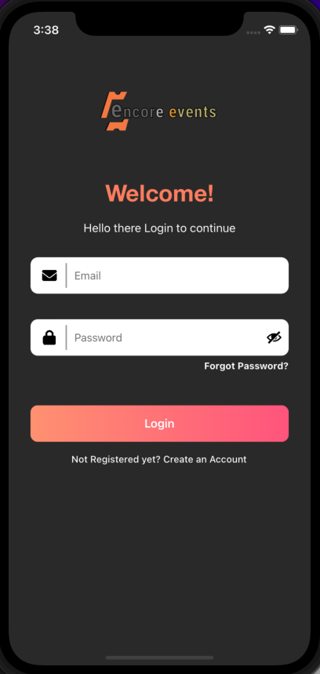

### Description:-

There will be also login page. Here user can login to system based on his email address and password. Based on his email address and password, application will identify his user dashboard. Super admin can see details of all users and manage their events.

1. Login using username & password

### User Registration Page

### 

### Description:-

There will be the registration page. Here user can register with their name, email, phone number, company and password. After resgister user can buy the event ticket.For sign we have added the user type for user and promoter.

### User Forget Password

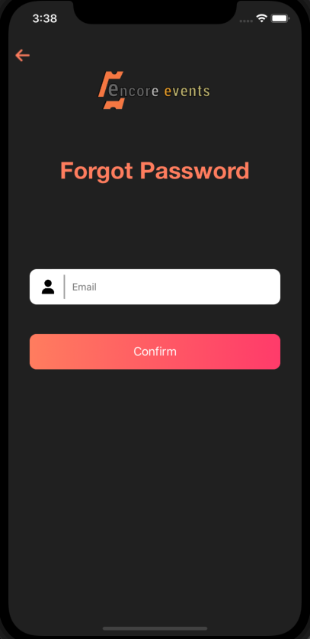

### Description:-

There will be a forgot password screen. If user somehow forgot his password then he can click on forgot password button. He need to enter his registered email id then a verification code will be sent to that email. He need to provide that verification code for further processing.

### User Reset Password

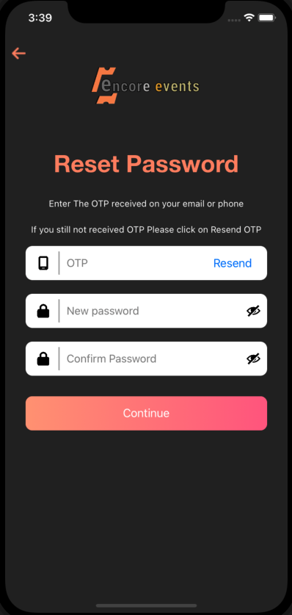

### Description:-

There will be a Reset password screen. If user want to change password then he can click on forgot password button. He need to enter his registered email id then a verification code will be sent to that email. He need to provide that verification code for further processing. After user can change their password.

### User Home Page

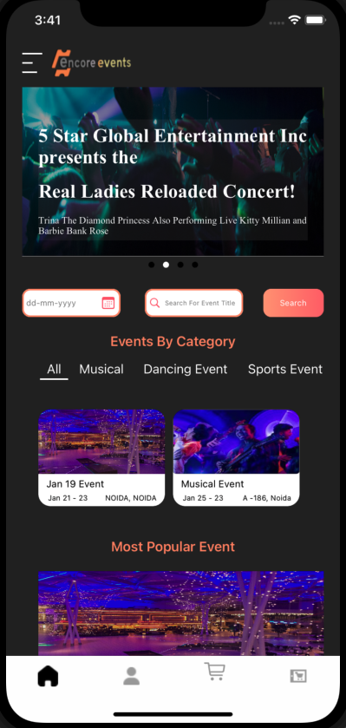

### Description:-

There will be Home page screen.Here all the running shows and event are visible to user and user check the event category and date and all the data for event.In Home Screen the user can search with date and event title and running events are visible on the banner.

### User Profile

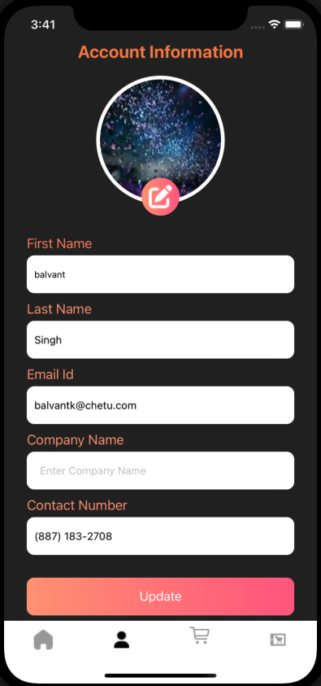

### Description:-

There will be a Profile screen. Here is the complete detail of user and user can change all the details exculing email and he can update their details any time.

It shows after login.

### User DashBoard

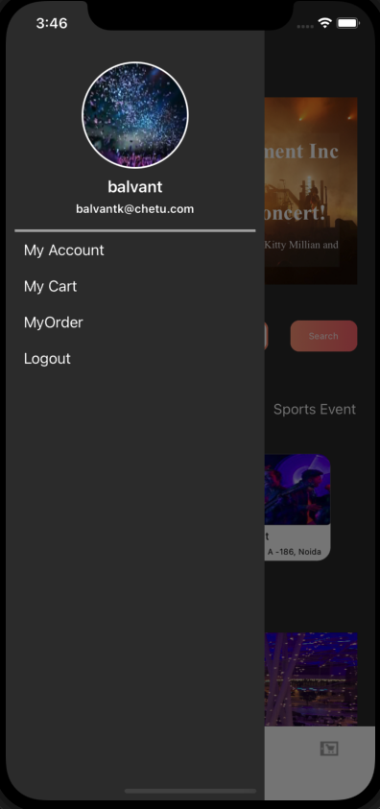

### Description:-

There will be User Dashboard where user can log in to the system based on his email address and password after that user dashboard page will open. The left sidebar shows the module and sub-modules list and when we click on any of them it shows the page related to selected modules in the right sidebar. In the Left sidebar basically, there are MyAccount, My Cart, My Order and Logout.

### Events Screen

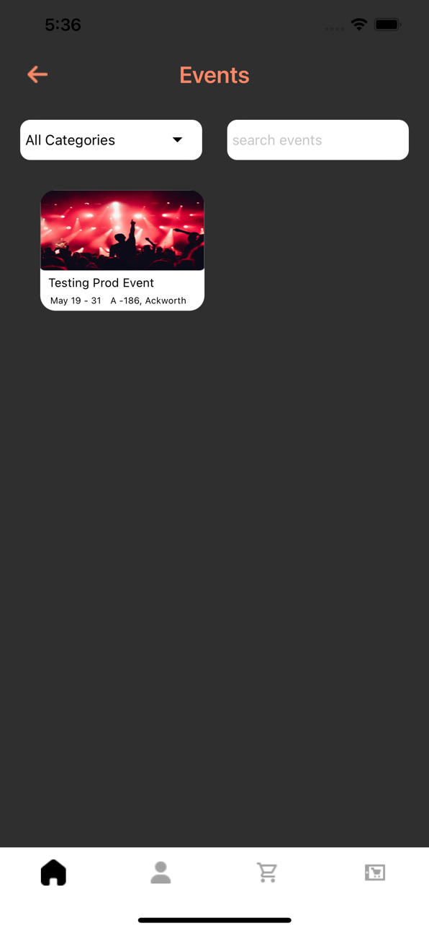

### Description:-

There will be a event screen which list out all the event details.This screen contains the event with event category we can filter the event with the event name and also we can filter the event using event category.If there is no event found we add the no record found in event screen.

### Buy Ticket

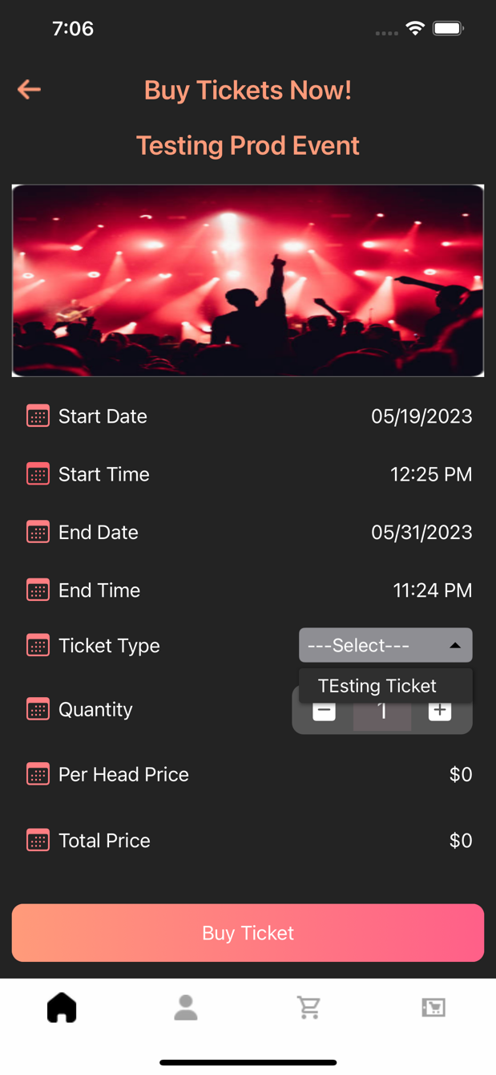

### Description:-

There will be the Buy ticket screen. In this screen user can chose the ticket for buy for event. In this screen we shows the event details with start date and end date we also show the per head price for ticket we choose the quantity of ticket which we want to purchase.

After click on Buy ticket we navigate to the cart screen.

### Cart screen

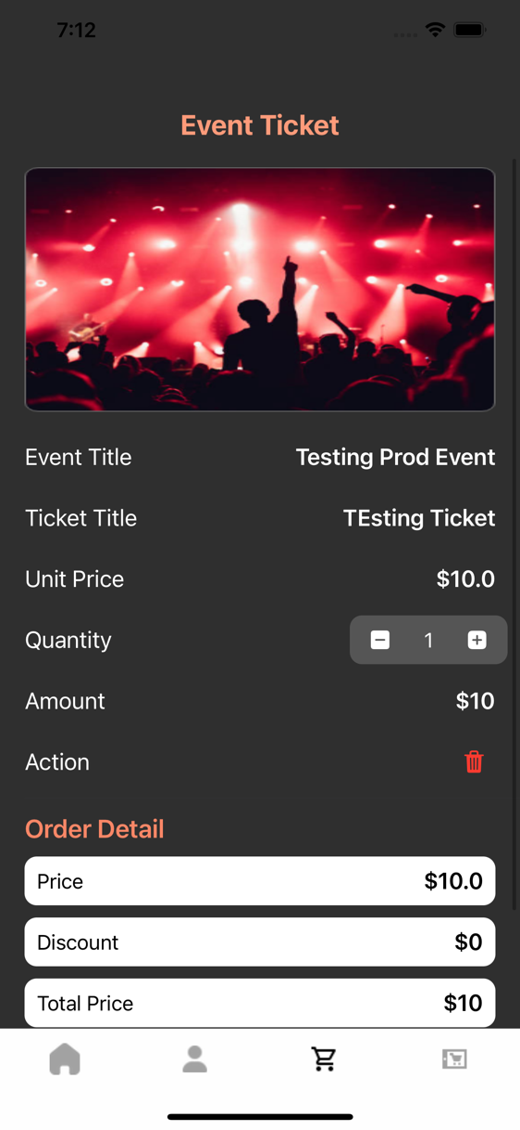

### Description:-

There will be the cart screen in application.This screen shows the details of event which you want to buy here we shows the event details with price and quantity we also add the stepper for increment and decrement the ticket and we also update the price with the ticket quantity.we add the place order button to place a order and navigate to payment checkout page.

### Payment Checkout

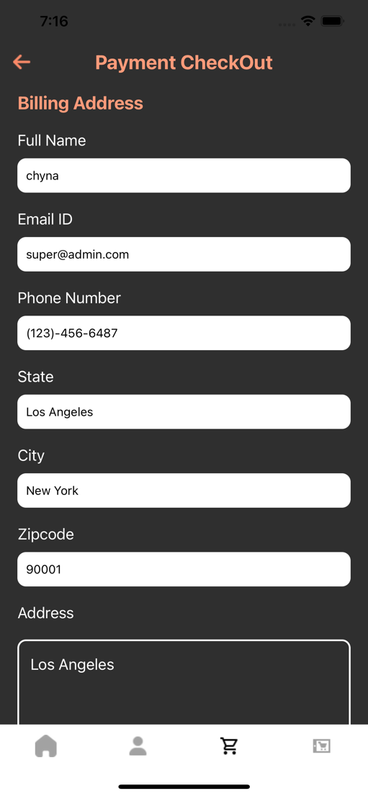

### Description:-

There will be the payment checkout page in application. This screen is shows the user details which should be enter by user . In this screen we shows the details like full name, email, phone number, state, city, zipcode and address. We add the place order button in this screen if the ticket is free we purchase the ticket on place order button if the ticket is paid we navigate to payment screen.

### Payment screen

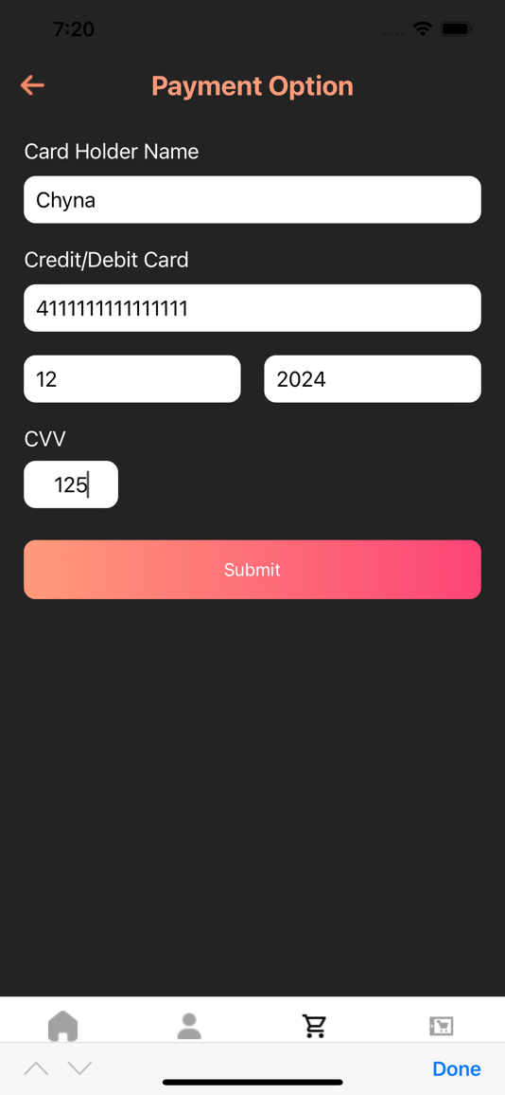

### Description:-

There will be the Payment screen. This screen is used to buy ticket. We implemented the stripe payment gateway to complete the payment. In this screen user need to enter the Card holder name, credit card number, expiry month, expiry year and cvv to complete the payment.

### Manage user

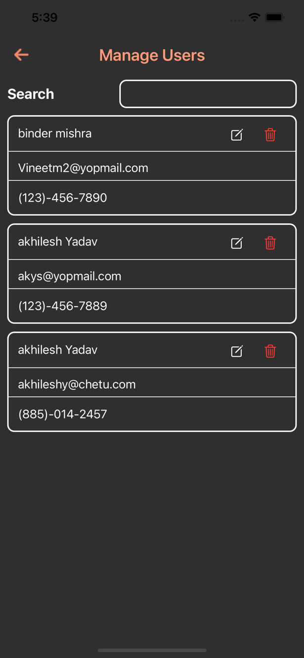

### Description:-

There will be the manage user screen which shows the user details for all the user who registered in the application in manage user screen we showing the user name, email and phone number we add the edit option and delet option.On edit button we edit the user profile and on delete button we delete the user and delete user is not showing in this list.

### Manage Promoter

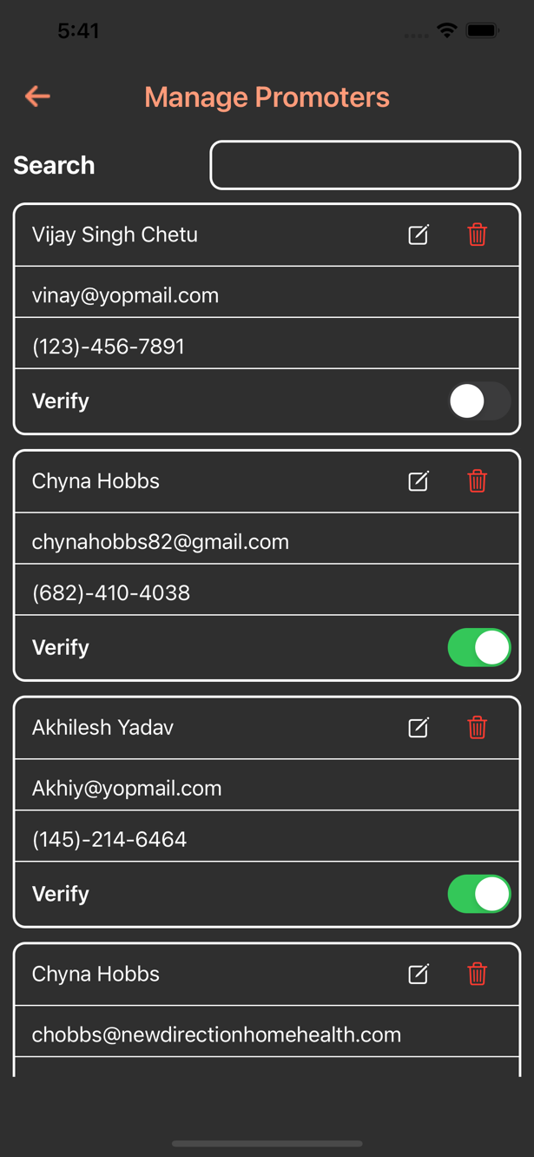

### Description:-

There will be the manage Promoter screen which shows the user details for all the promoter who registered in the application in manage Promoter screen we showing the promoter name, email and phone number we add the edit option and delet option.On edit button we edit the promoter profile and on delete button we delete the promoter and delete promoter is not showing in this list.

### Update User

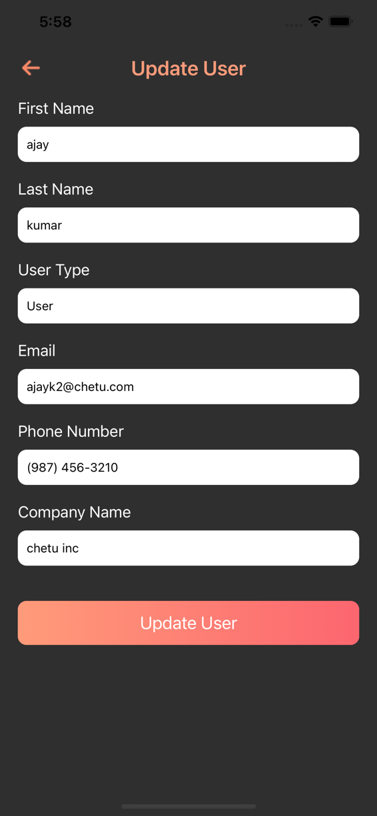

### Description:-

There will be the update user screen we can edit the user profile for this screen. This screen shows the user name, email , user type, phone number and company name. All fiied is required to update the user Profile. After update the user updated data is howing in manage user screen.

### Update Promoter

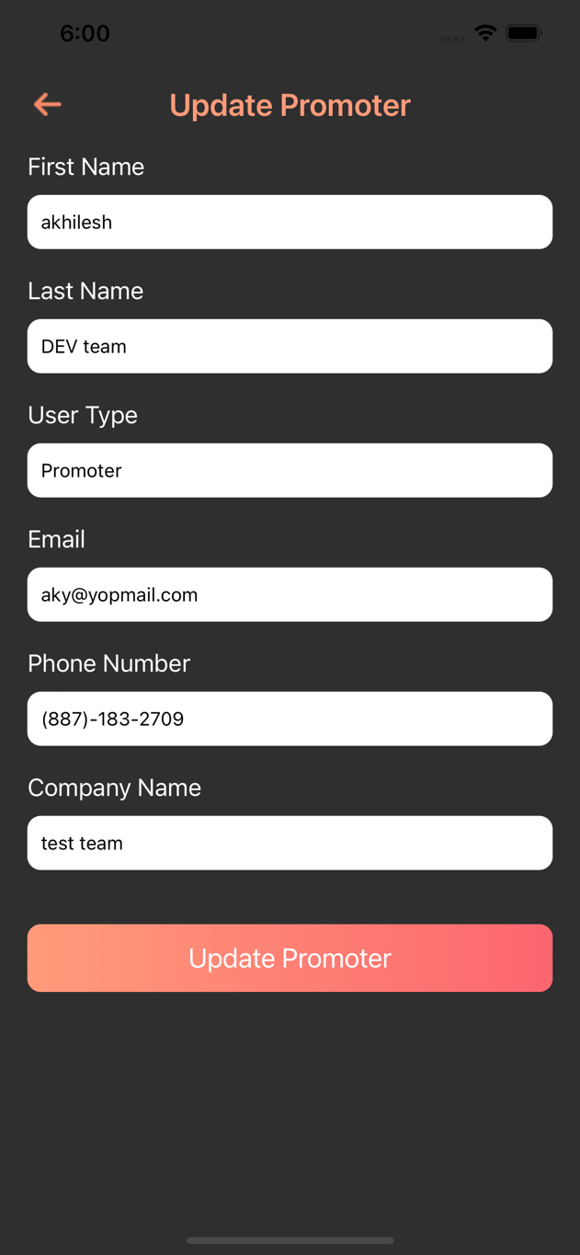

### Description:-

There will be the update promoter screen we can edit the promoter profile for this screen. This screen shows the promoter name, email , user type, phone number and company name. All fiied is required to update the user Profile. After update the promoter updated data is howing in manage promoter screen.

### Add Category

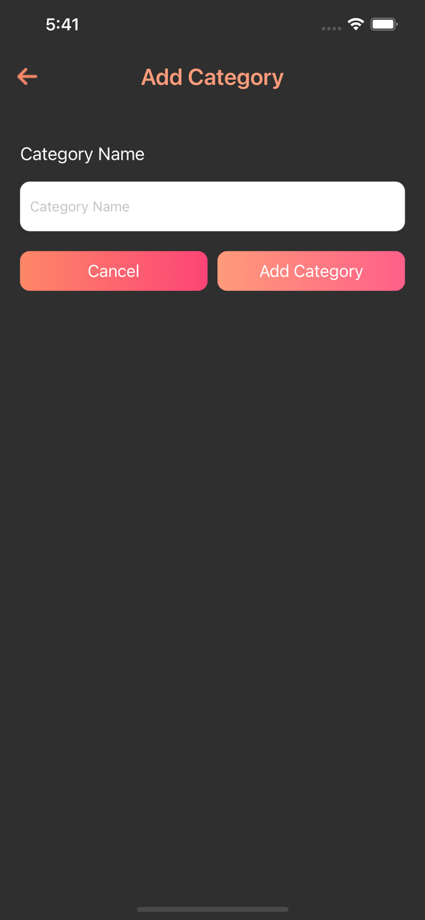

### Description:-

There will be the add category screen. This screen is used to add the category for event after adding the category it is showing in home screen in category section. For creating the event category is compulsory.

### Manage Category

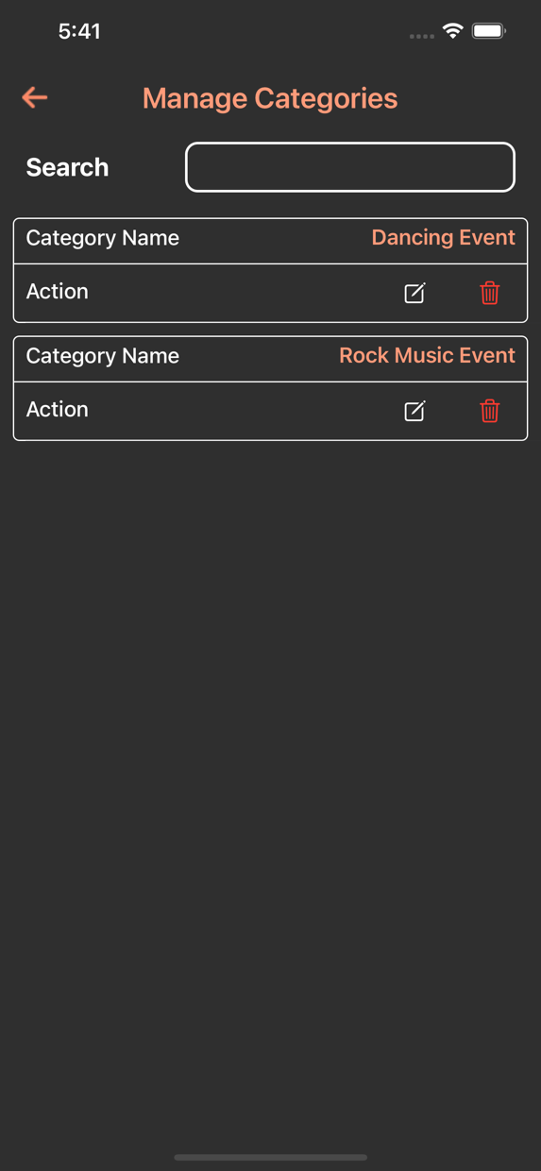

### Description:-

There will be the manage category screen. This screen shows the all category data which we have created. This screen shows the category name. We can edit and delete the category name after delete the category it is not showing in this screen.

### Update Category

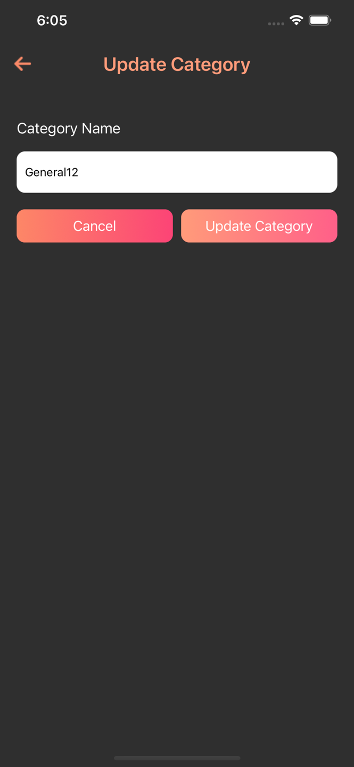

### Description:-

There will be the updaete category screen. In this screen we can update the category name. If we update the category name it will be reflect on manage category sceen otherwise the same name is appear in manage category screen.

### Update Event Charge

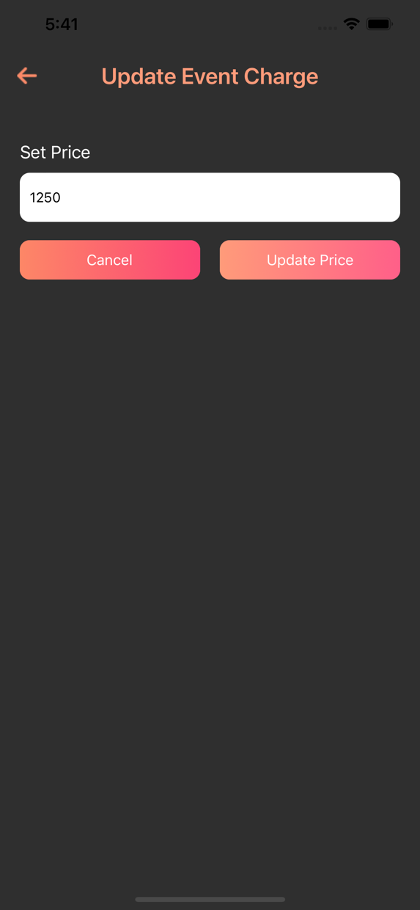

### Description:-

There will be the update event charge screen.This screen is only design for Admin.Only Admin can change the charge for the event if Admin change the amount of event then the promoter need to pay the amount that is decide for event.If the Admin change the price then the updated price is show on manage event screen else the price is same for the event.

### Create Event

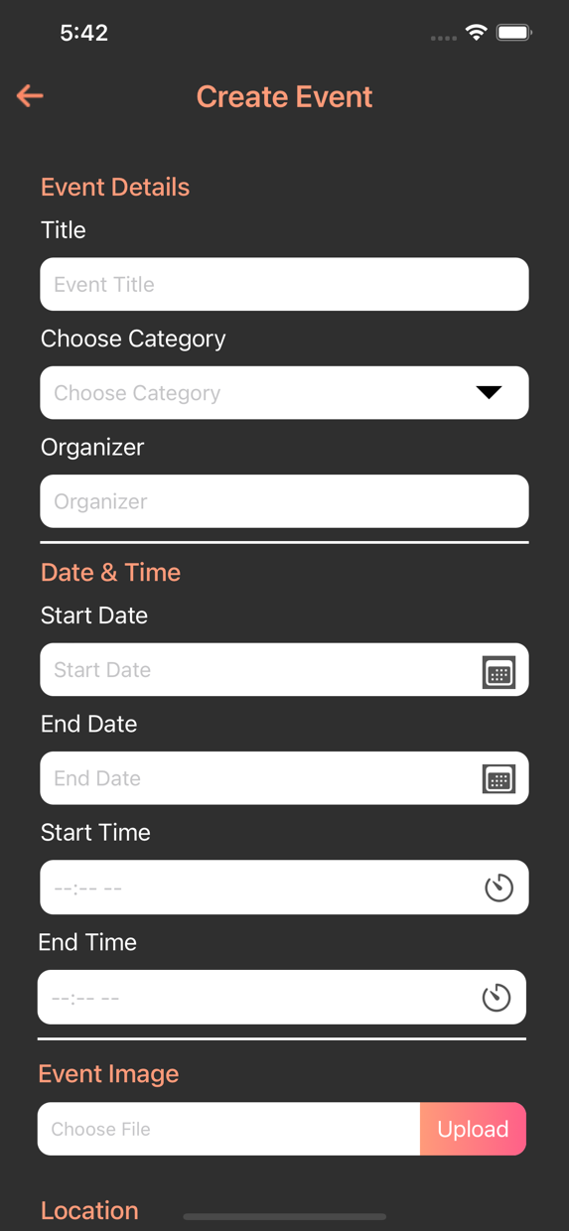

### Description:-

There will be the create event screen. This screen is designed for Admin and Promoter both for creating a event the you need to fill all the required filed eg. Event name, category, organizer, start/end date, start/end Time, event image, venue, zip code, description after created event is shown in manage event screen.

### Manage Event

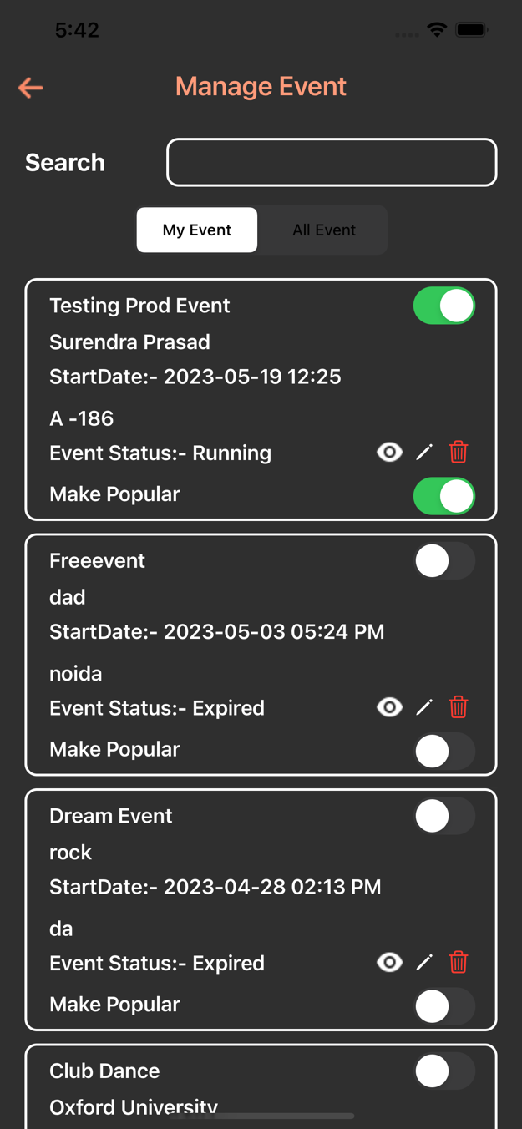

### Description:-

There will be the manage event screen.This screen shows the all the event which is created by admin and promoter. My event shows the promoter/admin self event and All event shows the all the event which is creatd by admin/promoter.In this screen we showing the event name Promoter name , start date, venue, event status. We also add the toggle for event status and make popular event. If we on the toggle of event then the event is live and shoing in home screen and if we popular the event the event is shown in popular event in home screen.

### Event detail Page

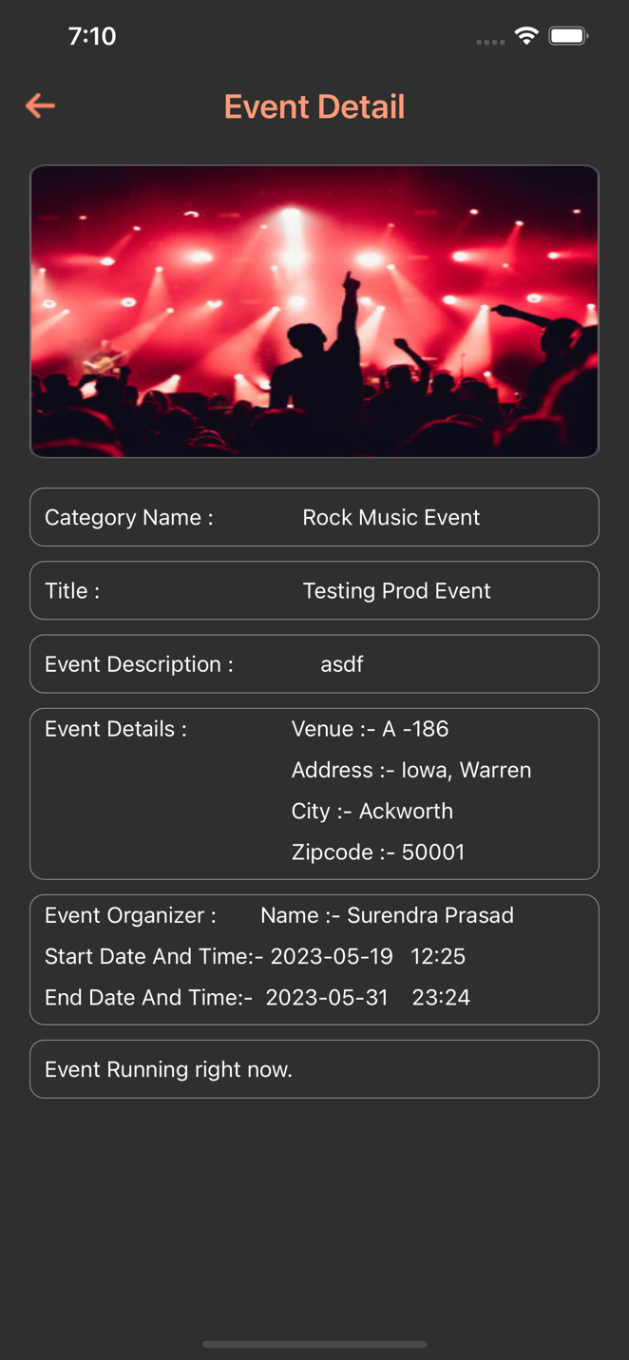

### Description:-

There will be the event details screen. This screen shows the all event details eg, category name, event title, eventy address, start date and end date we also implement the timer for running event.

### Update event

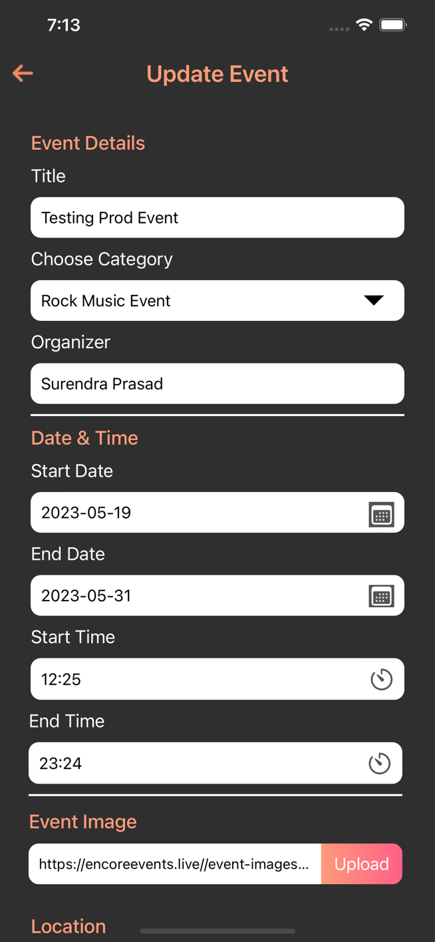

### Description:-

There will be the Update event screen. This screen is designed for Admin and Promoter both for can update event the you need to fill all the required filed eg. Event name, category, organizer, start/end date, start/end Time, event image, venue, zip code, description after created event is shown in manage event screen.

### Event Details with order

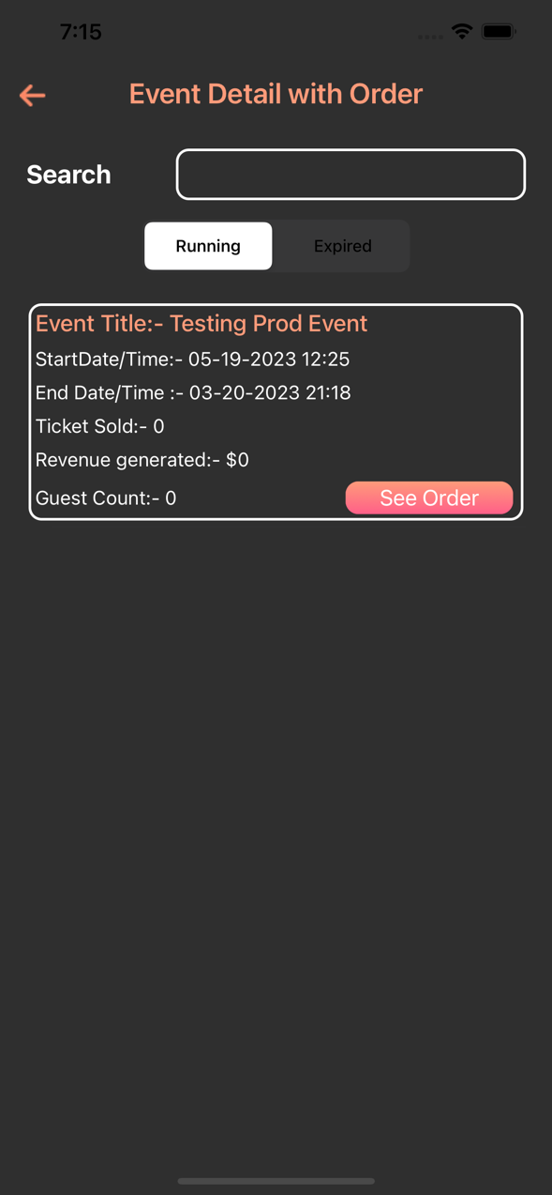

### Description:-

There will be the evnt details with order.This screen show the running and expired event details and we also add the see order button to shopwing the order details of event like ticket quantity and price for an event.This screen shows the total ticket sold for a particular event and revenue for ticket and how many guest joined the event.

### Order Detail

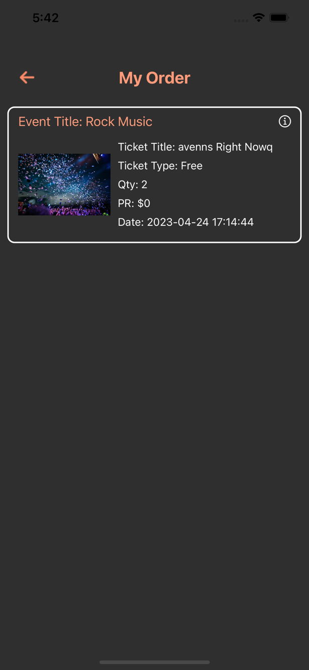

### Description:-

There will be the purchase oder details screen. This screen shows all the order detail which is odered by a user it show the ticket title and ticket type, Quantity, price and end date. We also add the information button to show the Qr- code details.

### Create Ticket

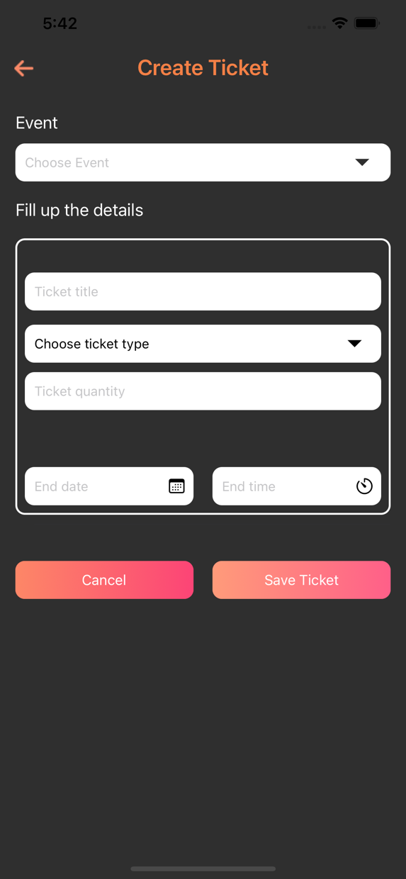

### Description:-

There will be the create ticket screen.this screen is used to create a ticket for a event .if we want to create a ticket we need to choose the event and ticket title and choose the ticket type Free/ Paid and price for a ticket we also need to enter the start and end date for event to create ticket.

### Manage Ticket

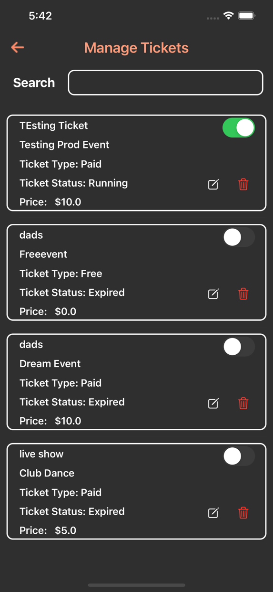

### Description:-

There will be the manage ticket screen. This screen show all the ticket details which is created by admin and promoter. We also add the toggle for change the status of ticket if we change the ticket status we can see the ticket title in buy ticket screen.

### Promotional list

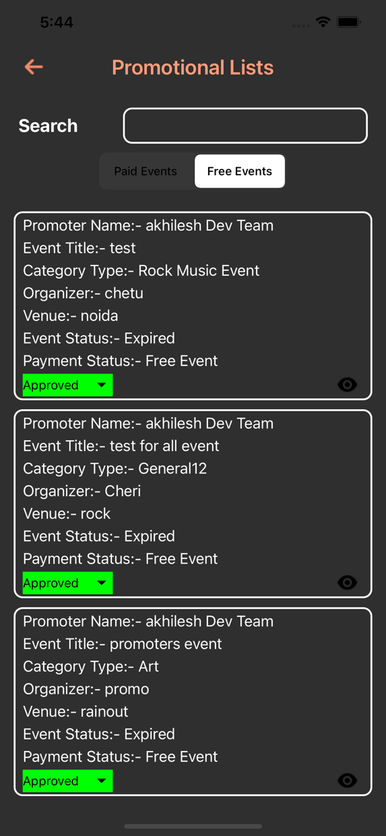

### Description:-

There will be the promotional list screen. This screen is used to access to prmoter to live the event without admin permission promoter can’t live the event there is two type of event in promotion list screen paid event and free event free event is created by own promoter and paid is by other promoter.we add the eye button to show the event details for event.

### Subscriber User list

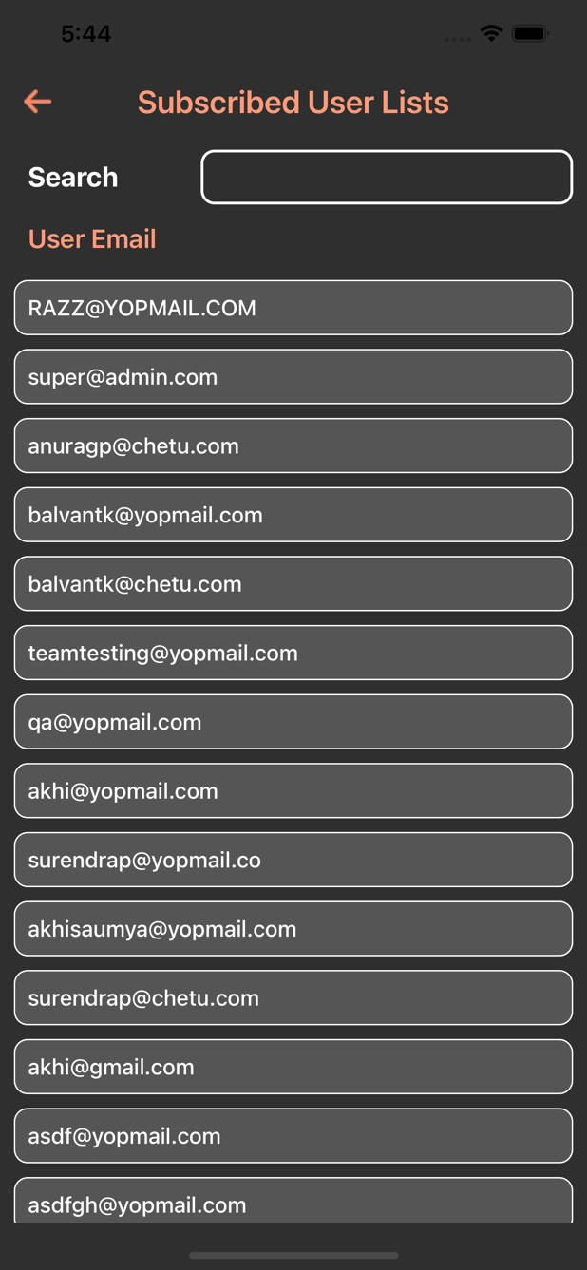

### Description:-

There will be the subscriber user list screen. This screen is used to show the subscriber user. If user subscribed in the application there email will be shown in subscriber user list screen.

### Add Banner

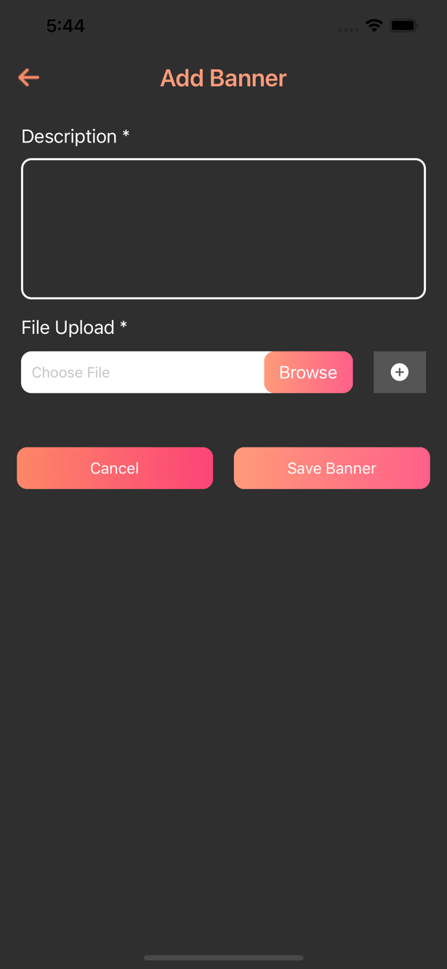

### Description:-

There will be the add banner screen. This screen is user to create a banner for event. If admin wants to create a banner for the event need to add description and image. On Click save banner banner is added in to manage banner screen.

### Manage banner

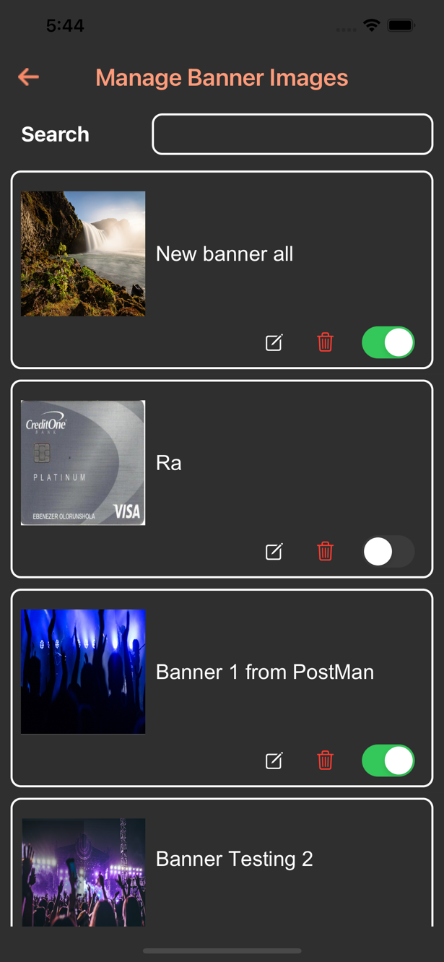

### Description:-

There will be the manage banner screen.This screen shows the banner detail which contains banner description and banner image. In this screen admin can edit and delete the banner we also add the toggle button to live/Unlive the banner status. If we change the banner status it will be appear on home screen.

### Scanner Ticket

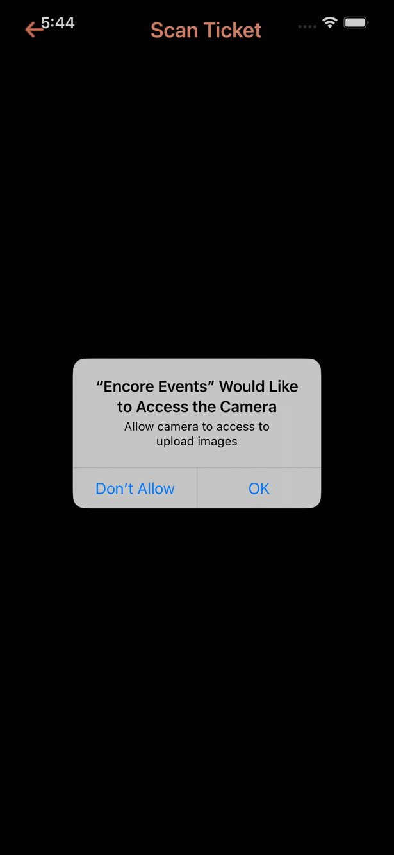

### Description:-

There will bet the scan Ticket screen.In this screen we scan the ticket which contains the QR-Code if we scan the ticket there will be different case.

1. If ticket is valid we shows the guest arrived screen.
2. If ticket is already scanned we shows the already scan ticket screen.
3. If ticket is wrong we navigate to wrong ticket screen.
4. If ticket is from different promoter we naviagate into this ticket is not belongs to your event screen.

### Contact Us

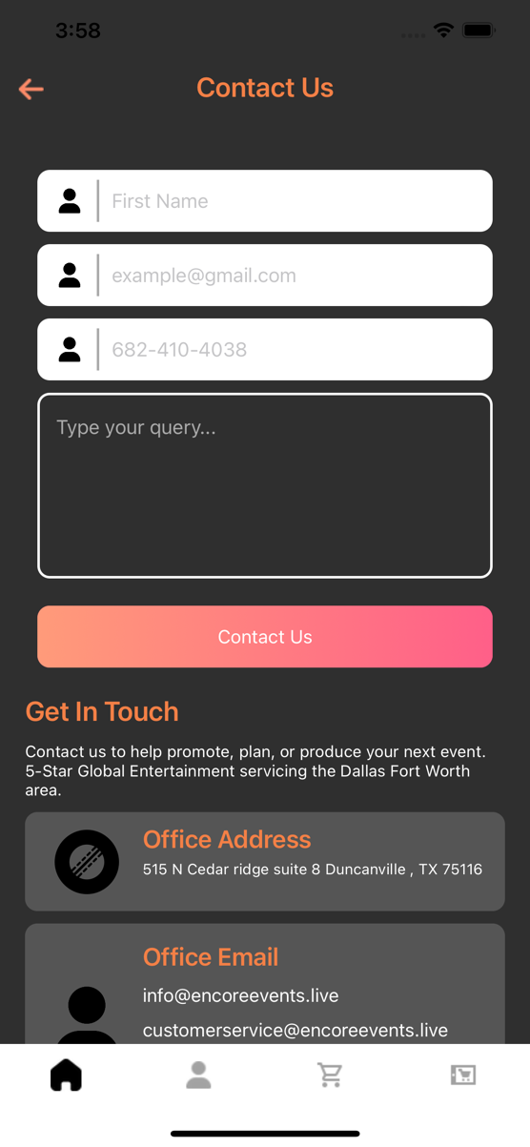

### Description:-

There will be the contact us screen. This screen is very usefull for user if user want to share any feedback and suggestion he need to enter name, email, phone number and description. After enter all the required field click on contact button after click on contact us button his/ her query send to admin. Admin can get his query in email.

Change/Update Track Record. (According to Date)

25/05/2023 – Changed By Vineet Mishra